**PROJECT REPORT TITLE**

**Title: A CRM Application For School/College**

**1.Introduction**

**1.1 Overview**

The project aim is to provide real-time knowledge for all the students who have basic knowledge of Salesforce and Looking for a real-time project. This project will also help those professionals who are in cross-technology and want to switch to Salesforce. With the help of this project they will gain knowledge and can include it into their resume as well.

1.2 Purpose

This Project helps you to maintain and manage the school related problems which further can be modified based on the requirements.

**2. Problem Definition & Thinking**

2.1 Empathy Map:

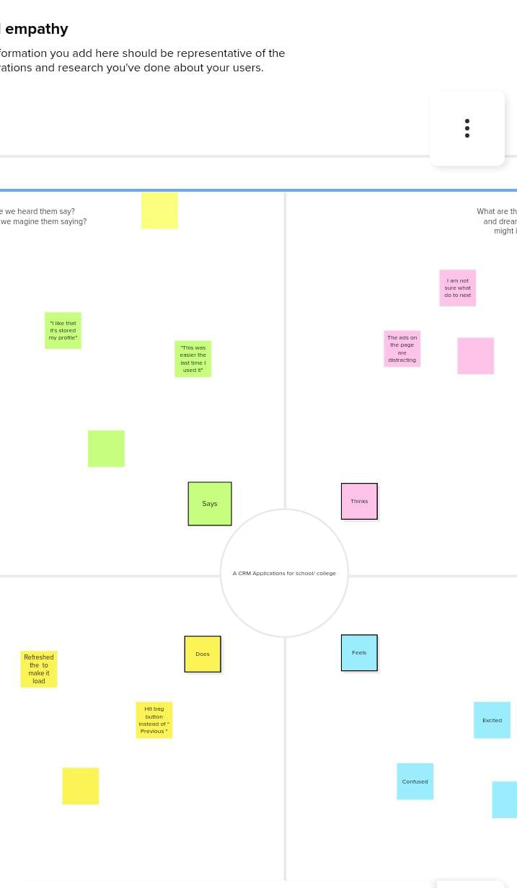

2.2 Brainstorming & Thinking:

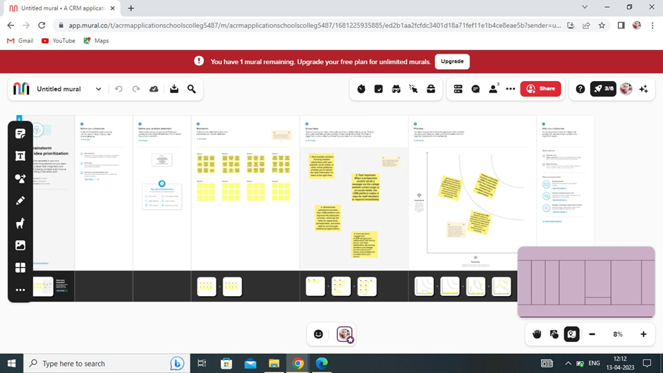

**3. Result**

3.1 Data Model:

|  |  |
| --- | --- |
| Object Name | Field In The Object |
| School Name | |  |  | | --- | --- | | Field Label | Data Type | | School | Text | |
| Phone Number | |  |  | | --- | --- | | Field Label | Data Type | | Phone Number | Phone | |
| School Name | |  |  | | --- | --- | | Field Label | Data Type | | School | Text | |

4. Trailhead profile public URL:

**Team Leader :** [**https://trailblazer.me/id/aswik8**](https://trailblazer.me/id/aswik8)

**Team Member 1:**

**Team Member 2:** <https://trailblazer.me/id/madep7>

**Team Member 3:** <https://trailblazer.me/id/mnantham>

**5.Advantages & Disadvantages:**

**Advantages:**

* It reduces stress.
* It saves our time.
* We can manage school and college related problems.

**Disadvantages:**

* If the server is overload it might tough to access the data.

**Applications:**

* This software is used to rectify the school/college related problems.
* We can store the students details for future purpose.
* Which data is used to tell the infrastructure of the college/school.
* And approach them to join the college/school.

**Future Scope:**

Now a days many of the institutions preferring online application forms.In that form every student must fill up their communication mobile number and Mail Id.From that data we can able to contact our candidates immediately.